
Repsol Eco-Fuels Demand Forecasting Project
Macro Demand Forecast for Diesel Nexa / Biodiesel in Spain
Forecast horizon: January 2026 to December 2027
Geographic scope: Spain, Madrid, Catalonia, Andalusia, and Valencia
29 June 2026

Ethics statement: This report uses public or project-provided datasets, avoids personal data, documents uncertainty transparently, and presents forecasts as decision-support estimates rather than deterministic claims.
AI disclosure: AI tools supported drafting, structuring, formatting, and quality review. Analytical outputs and interpretations were checked against repository artifacts and validation scripts.

Executive Summary
This project develops a monthly demand forecasting framework for Diesel Nexa / biodiesel demand in the Spanish market. The aim is to estimate demand over a 24-month horizon, from January 2026 to December 2027, at both national and regional levels.
The project combines several data sources into a single analytical pipeline: biodiesel consumption, macroeconomic indicators, Brent oil prices, fuel retail prices, and CNMC petroleum context variables. These sources are consolidated into a monthly master dataset using Fecha and CCAA as the primary keys.
A single insight shapes the whole approach. The consumption series being forecast captures biodiesel sold as its own labelled product, not biodiesel blended invisibly into ordinary diesel, so it behaves like the adoption curve of a new product category rather than the demand for a mature, stable fuel. This is why saturating growth curves (Logistic and Gompertz) are natural candidates for the national, Madrid, and Valencia series, and why a benchmark such as R2, which measures improvement over a flat historical average, is a poor fit for a series still in its growth phase (see Section 6.2). It does not, on its own, explain the two regions where a time-series model (SARIMA) was selected instead; those are a structurally different case, discussed in Sections 5.6 and 5.9.
The final modeling framework evaluates statistical time-series models, growth-curve models, and machine-learning models. The selected model is chosen separately for each target series because biodiesel adoption does not evolve uniformly across Spain.
The final selected models are:
Target | Selected Model | MAE | RMSE | MAPE | R2
Nacional | Logistic | 6,228.7 | 6,999.4 | 36.7% | -1.041
Madrid | Logistic | 1,924.0 | 2,057.2 | 73.6% | -8.273
Cataluña | SARIMA | 1,557.8 | 1,794.1 | 50.1% | -7.182
Andalucía | SARIMA | 898.8 | 1,077.9 | 52.6% | -1.929
Valencia | Gompertz | 360.3 | 446.6 | 34.2% | -1.246

The forecasts suggest continued national demand growth through 2026 and 2027. However, the results must be interpreted with caution because the available time series is short and the biodiesel market appears to be in an adoption-stage regime rather than a mature stable-demand regime.

1. Objective

1.1 Problem Definition
Repsol operates in an energy market shaped by decarbonization, regulatory pressure, fuel substitution, and changing customer expectations. Eco-fuels such as Diesel Nexa are strategically important because they may support lower-carbon mobility while using existing liquid-fuel infrastructure.
The business problem is that Diesel Nexa / biodiesel demand is difficult to forecast with traditional methods. The available data shows strong growth from a limited historical base, and the market does not yet behave like a mature fuel category. This creates uncertainty for commercial planning, supply preparation, and regional prioritization.
The core forecasting challenge is therefore:
How can monthly Diesel Nexa / biodiesel demand be forecasted for Spain and selected regions over the next 24 months using the available historical, macroeconomic, energy-price, and petroleum-context data?

1.2 Aim of the Work
The aim of the project is to build a reproducible forecasting pipeline that:
- Consolidates all relevant data sources into a consistent monthly analytical dataset.
- Produces model-ready features for national and regional demand forecasting.
- Evaluates multiple forecasting approaches rather than relying on a single algorithm.
- Selects the most appropriate model for each target market.
- Generates 24-month forecasts for 2026 and 2027.
- Communicates results in a way that is useful for both technical and business audiences.

1.3 Forecasting Scope
The forecasting scope includes five target series:
- Spain as a national market.
- Madrid.
- Catalonia.
- Andalusia.
- Valencia.
The final forecast horizon is monthly from 2026-01 to 2027-12.

1.4 Target Variable
The dependent variable is Consumo_Tm, measured in metric tons. In this project, it represents distinct biodiesel consumption reported as its own product line. It should not be interpreted as the total biodiesel fraction blended into all diesel products.
This definition matters because a blended biodiesel-content metric would describe renewable content across conventional diesel. The project target is closer to a product adoption and commercialization problem.

1.5 Expected Use of the Forecast
The forecast is intended to support:
- Medium-term commercial planning.
- Regional demand monitoring.
- Strategic supply and capacity discussions.
- Scenario interpretation for energy and fuel-price context.
- Identification of future data needs.
The forecast is not intended to be used alone for:
- Daily operational scheduling.
- Contract-level volume commitments.
- Causal policy evaluation.
- Pricing optimization without additional modeling.

2. Data Sources

2.1 Overview
The project uses multiple data sources to represent demand, macroeconomic context, energy-market context, and petroleum-market context. The sources have different original granularities, so preparation and alignment are required before modeling.
The biodiesel consumption series is reconciled, exactly and on every pipeline run, against CNMC's raw provincial petroleum-consumption files. CNMC is therefore the project's verified, reproducible source for the target series and is the primary entry in the table below. CORES biofuel-certification records exist in the project's raw data folder as historical reference material, but no notebook or script in the reproducible pipeline reads them, and no current (2025-dated) CORES file of that type exists in the project; CORES is kept for context, not as a pipeline input.
Data Source | Main File / Output | Role in the Project
CNMC petroleum consumption (biodiesel target series) | data/inputs/consumo_biodiesel_ccaa.csv | Core monthly demand series by autonomous community. Reconciles exactly with CNMC's raw provincial files; this is the verified, reproducible lineage for the project's target.
Target demand series | data/inputs/consumo_biodiesel_targets.csv | Modeling targets for Spain, Madrid, Catalonia, Andalusia, and Valencia.
INE macroeconomic indicators | data/inputs/macro_indicadores_ine.csv | Industrial production, inflation, and unemployment context.
Brent oil prices | data/inputs/brent_oil_price_monthly_2023_onwards.csv | International crude oil price context.
Fuel retail prices | data/inputs/precios_combustibles_2023.csv, 2024.csv, 2025.csv | Regional gasoline and diesel price signals.
CNMC diesel-pool context | Integrated in data/inputs/master_dataset.csv | Diesel-pool ratio variables connecting biodiesel demand to the broader diesel market.
CORES biofuel certification (historical reference, not in the reproducible pipeline) | Not read by any notebook or script | Historical/supplementary certification records kept in the project's raw data folder for context; superseded by the CNMC reconciliation above as the project's lineage source.

2.2 Consumption Data
The consumption data is the core of the forecasting problem. It provides monthly biodiesel demand by autonomous community. This dataset is used to create the national and regional target series.
Main columns:
- Fecha
- CCAA
- Consumo_Tm
The monthly structure allows the project to model trend, seasonality, lags, and rolling demand behavior.

2.3 Macroeconomic Data
The macroeconomic data comes from INE indicators and includes variables such as:
- IPI_original
- IPI_ajustado
- IPC_var_anual
- Tasa_paro
These variables provide economic context. Industrial production may reflect economic activity, inflation may affect consumption conditions, and unemployment may capture broader economic pressure.

2.4 Energy and Fuel Price Data
The project includes Brent oil prices and fuel retail prices. Fuel prices are important because biodiesel adoption may be influenced by relative fuel economics, customer substitution behavior, and broader energy-market conditions.
The fuel-price files are originally more granular than the modeling table. They are processed and aggregated into monthly variables by autonomous community.
Examples of final price-related columns include:
- Precio_Brent_USD
- PVP_Gasoleo_A
- PVP_Gasoleo_Premium
- PVP_Gasolina95
- PVP_Gasolina98
- PAI_Gasoleo_A
- PAI_Gasolina95

2.5 CNMC Petroleum Context
CNMC petroleum data provides additional context around biodiesel and diesel-pool behavior. This is useful because Diesel Nexa / biodiesel demand should be interpreted in relation to the broader diesel market. As noted in Section 2.1, CNMC is also the reconciled, verified source for the target series itself, not only for this contextual ratio data.
Examples of integrated variables include:
- CNMC_Biodiesel_Tm
- GasoleoA_Tm
- DieselPool_Tm
- Ratio variables connecting biodiesel to the broader diesel pool.

2.6 Master Dataset Construction
The final master dataset is saved as:
data/inputs/master_dataset.csv
Current dimensions:
- 720 rows.
- 22 columns.
- 20 autonomous communities / national entities.
- Monthly coverage from 2023-01 to 2025-12.
The master dataset uses two primary keys:
- Fecha
- CCAA
Each row represents one month and one autonomous community. This design allows the same dataset to support national analysis, regional analysis, feature engineering, and model training.

2.7 Data Preparation and Processing
The main preparation steps are:
1. Clean and standardize biodiesel consumption data.
2. Normalize date columns into a monthly YYYY-MM format.
3. Standardize region names in CCAA.
4. Aggregate fuel prices from granular raw files into monthly regional values.
5. Align macroeconomic indicators by month.
6. Merge all compatible sources using Fecha and CCAA.
7. Preserve missing values where a data source cannot fully cover all regions or months.
The decision to preserve missing values is important. Dropping rows would reduce the already short time series and could bias regional coverage.

2.8 Modeling Dataset
The feature-engineered modeling dataset is saved as:
data/features/features_modelo_completo.csv
Current dimensions:
- 180 rows.
- 35 columns.
- 5 target series.
- Monthly coverage from 2023-01 to 2025-12.
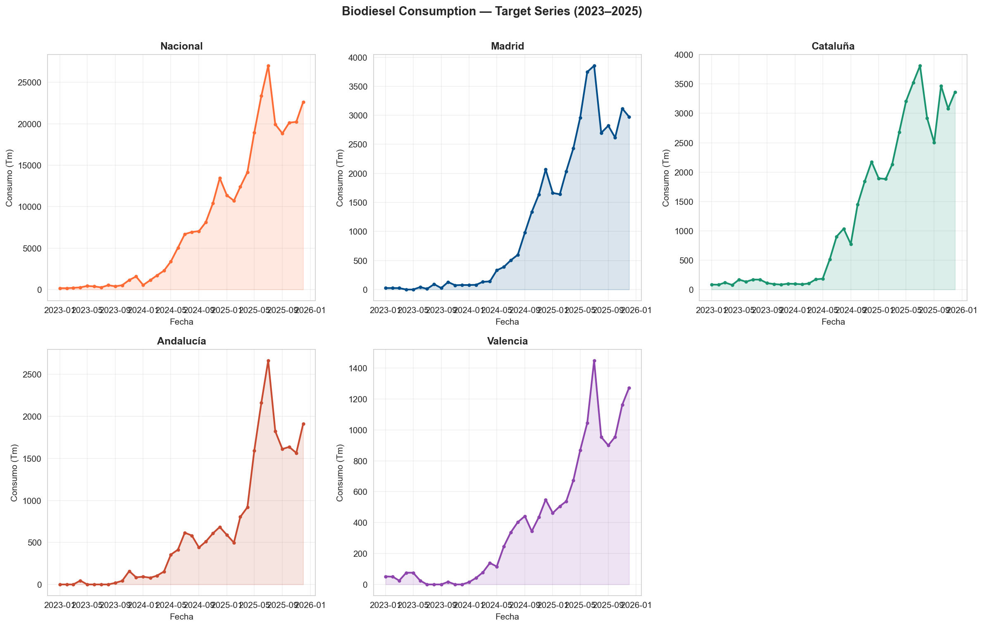
National and regional demand trend, 2023-2025 (the project's 5 modeled series: Nacional, Madrid, Cataluña, Andalucía, Valencia)

3. Methodology

3.1 Technical Environment
The project uses a Python-based analytical workflow supported by GitHub version control and notebook-based exploration.
Main tools:
- Python for data processing, feature engineering, modeling, and evaluation.
- pandas and NumPy for data manipulation.
- statsmodels for statistical time-series modeling.
- scikit-learn for machine-learning models and evaluation.
- XGBoost for gradient-boosted tree modeling.
- matplotlib / seaborn for visual analysis.
- GitHub for version control.
- Jupyter notebooks for exploratory and explanatory workflow.

3.2 Pipeline Structure
The project pipeline follows a staged structure:
1. Data cleaning.
2. External data acquisition and preparation.
3. Master dataset construction.
4. Feature engineering.
5. Candidate model training.
6. Model selection and validation.
7. Forecast generation.
8. Business interpretation and reporting.
This structure separates data preparation from modeling, reducing the risk of mixing exploratory logic with final outputs.

3.3 Feature Engineering Methodology
Feature engineering converts the master dataset into a target-level modeling table. The main feature groups are:
- Calendar features: year, month, trend, and seasonal encoding.
- Lag features: previous demand values.
- Rolling features: trailing demand averages.
- Macroeconomic features: industrial production, inflation, and unemployment.
- Fuel-price features: gasoline and diesel price signals.
- Energy-context features: Brent and diesel-pool indicators.
A key rule is to prevent look-ahead leakage. Lag and rolling features are constructed so that each forecast only uses information available before the forecasted month.
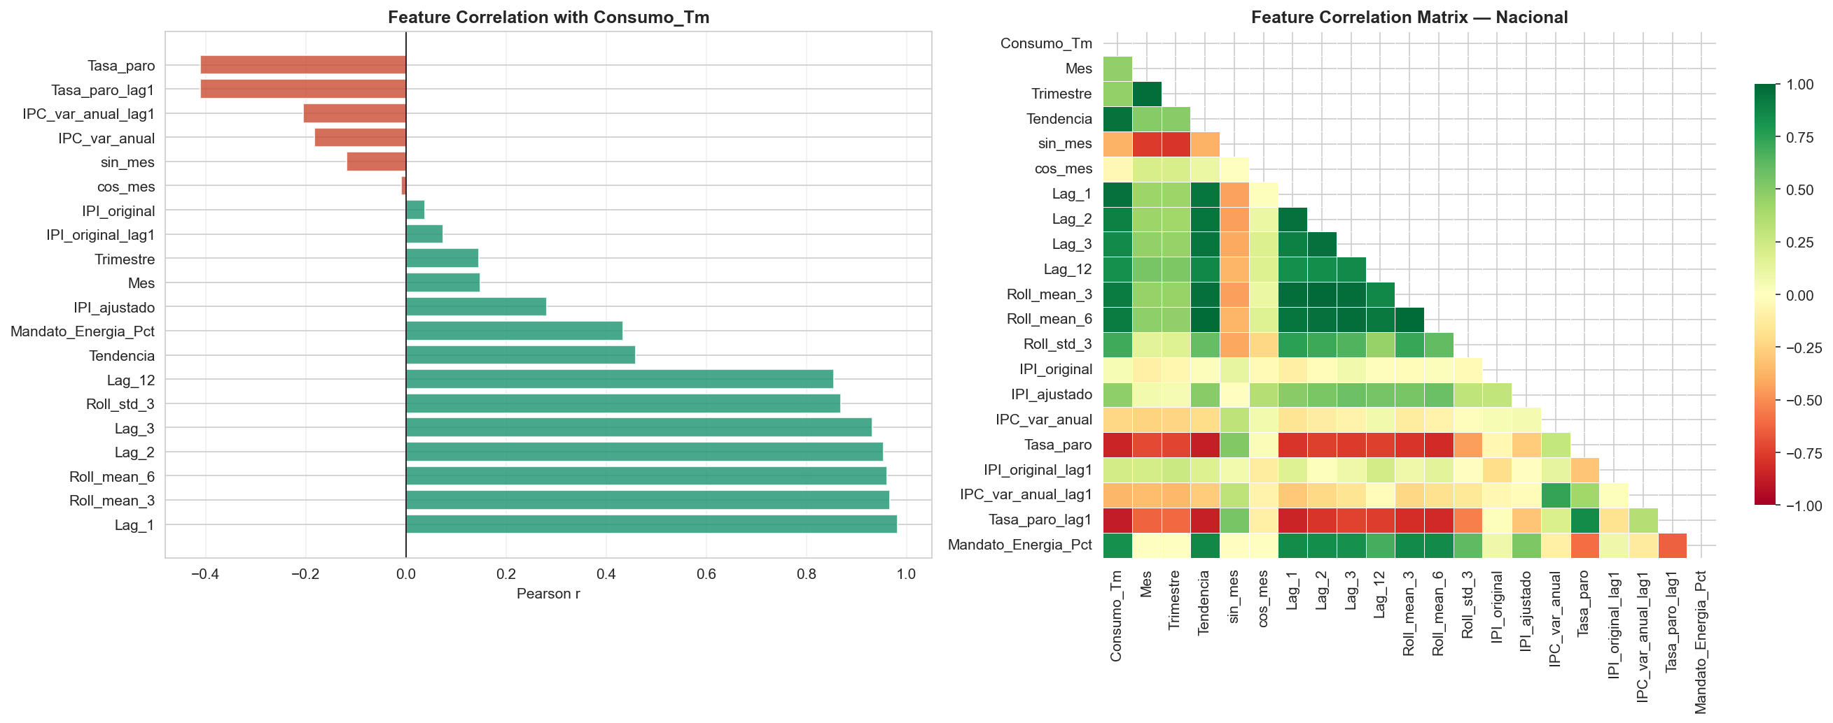
Feature correlations

3.4 Validation Methodology
The model selection process uses recursive multi-step walk-forward validation inside the 2023-2024 training period. The year 2025 is used as a holdout test set after the selected model has already been fixed.
This is important because it prevents the final evaluation period from influencing the selected model.
The final metrics are:
- MAE: mean absolute error.
- RMSE: root mean squared error.
- MAPE: mean absolute percentage error.
- R2: holdout explanatory score.
In this project, MAE, RMSE, and MAPE are more useful than R2 because the holdout period is short and the series can shift regime.

3.5 Model Reliability Controls
The pipeline includes safeguards to avoid presenting unstable models as final results:
- Degenerate statistical fits are rejected.
- Non-convergent SARIMA / SARIMAX fits are documented.
- Very low-variance fits are excluded from headline model selection.
- Pooled regional machine-learning models are treated as diagnostics rather than final selected models.
These safeguards are necessary because short time series can make complex models look artificially convincing.

4. Potential Solutions

4.1 Alternative 1: Single Time-Series Model for Every Region
The first possible solution was to use a single time-series model family, such as SARIMA, for every target series.
Advantages:
- Easy to explain.
- Strong fit for monthly time-series behavior.
- Handles trend and seasonality.
- Requires fewer external assumptions.
Disadvantages:
- May not capture adoption-curve behavior.
- May fail when a region has a structural demand shift.
- Does not use external drivers unless extended to SARIMAX.
This alternative was useful as a baseline but too restrictive for the full project.

4.2 Alternative 2: Machine-Learning Model With External Drivers
The second possible solution was to use machine-learning models such as Random Forest or XGBoost with macroeconomic, fuel-price, and lag features.
Advantages:
- Can capture non-linear relationships.
- Can use many explanatory variables.
- Can identify feature importance.
- Flexible across regions.
Disadvantages:
- Requires more data than available.
- Can struggle to extrapolate outside the training range.
- May overfit short time series.
- Recursive long-horizon forecasting can compound error.
This alternative was technically valuable, but it was not reliable enough to be the only forecasting approach. Section 5.7 quantifies exactly why, with the project's own evidence.

4.3 Alternative 3: Growth-Curve Models for Adoption Behavior
The third possible solution was to use growth-curve models such as Logistic and Gompertz models.
Advantages:
- Well-suited for adoption-stage demand.
- Can represent growth that slows over time.
- More realistic than unlimited linear or exponential extrapolation.
Disadvantages:
- Requires assumptions about saturation behavior.
- May underperform if demand has strong seasonality.
- Can be sensitive to the short historical window.
This alternative was important because biodiesel demand behaves like an adoption-stage product in several target markets.

4.4 Chosen Solution
The final solution is a model-comparison framework rather than a single-model approach. The project evaluates multiple candidate models and selects the best usable model separately for each target.
Candidate model families:
- SARIMA
- SARIMAX
- Logistic growth curve
- Gompertz growth curve
- Ridge regression
- Random Forest
- XGBoost
This approach is more appropriate because each region can behave differently. Madrid and the national market may follow adoption-curve dynamics, while Catalonia and Andalusia may be better represented by time-series dynamics. A pooled regional variant of the machine-learning candidates is also evaluated as a diagnostic comparison; Section 5.10 explains why it is not eligible to be the headline model even where it scores better, by design rather than by performance.

5. Development

5.1 Repository Workflow
The project is organized into data folders, notebooks, scripts, outputs, and figures. The workflow is designed so that each phase produces an intermediate artifact used by the next phase.
Main folders:
- data/inputs: original and consolidated input datasets.
- data/features: model-ready feature datasets.
- data/outputs: model metrics, forecasts, diagnostics, and scenario outputs.
- notebooks: exploratory and explanatory notebooks.
- scripts: production-style pipeline scripts.
- reports/figures: generated visual outputs.

5.2 Core Development Logic
The pipeline logic can be summarized as:
# 1. Load master dataset
df_master = pd.read_csv("data/inputs/master_dataset.csv")
# 2. Filter target rows
df_targets = df_master[df_master["Target"] == 1].copy()
# 3. Build time-series features, grouped by Target (the 5 modeled
# series), with the same null-handling the production script uses
df_targets["Lag_1"] = df_targets.groupby("Target")["Consumo_Tm"].shift(1)
df_targets["Roll_mean_3"] = (
df_targets.groupby("Target")["Consumo_Tm"]
.shift(1)
.rolling(window=3, min_periods=2)
.mean()
)
# 4. Train candidate models
# 5. Validate with walk-forward logic
# 6. Select the best usable model per target
# 7. Generate 24-month forecasts
This code structure emphasizes reproducibility and clarity. Each major output is saved to disk so that results can be audited and reused.

5.3 Model Families Implemented
SARIMA and SARIMAX are used to model temporal structure. Logistic and Gompertz models are used to capture adoption-curve behavior. Ridge, Random Forest, and XGBoost are used as machine-learning baselines with external variables.
The final selected models are:
Target | Final Selected Model | Interpretation
Nacional | Logistic | National demand behaves like an adoption curve.
Madrid | Logistic | Madrid demand is better represented by bounded growth, although error remains high.
Cataluña | SARIMA | Recent time-series dynamics are more useful than growth-curve assumptions.
Andalucía | SARIMA | Recent time-series behavior produces the selected forecast.
Valencia | Gompertz | Valencia appears to retain adoption-stage growth momentum.

5.4 Development Outputs
The main development outputs are:
Output | Path | Description
Master dataset | data/inputs/master_dataset.csv | Unified monthly CCAA dataset.
Feature dataset | data/features/features_modelo_completo.csv | Final modeling feature table.
Selected model metrics | data/outputs/metricas_final_selected.csv | Final holdout metrics by target.
Selected 24-month forecast | data/outputs/forecast_24m_selected.csv | Final selected-model forecasts.
Scenario sensitivity | data/outputs/scenario_sensitivity.csv | Scenario-level forecast sensitivity outputs.
Residual diagnostics | data/outputs/ljung_box_residual_diagnostics.csv | Statistical residual checks.
Safety checks | data/outputs/sarima_safety_check.csv | SARIMA fit diagnostics.
Selected model vs. seasonal-naive baseline | data/outputs/selected_model_mase.csv | MASE and seasonal-naive MAE comparison underlying the R2 note in Section 6.2.

5.5 Forecast Results
The selected 24-month forecast contains 120 rows:
- 5 target series.
- 24 forecast months.
- One selected model per target.
Annual forecast totals:
Target | Model | 2026 Forecast Tm | 2027 Forecast Tm
Nacional | Logistic | 310,495.3 | 323,727.8
Madrid | Logistic | 44,848.1 | 46,007.7
Cataluña | SARIMA | 40,654.4 | 40,778.0
Andalucía | SARIMA | 25,434.8 | 25,046.3
Valencia | Gompertz | 17,656.5 | 20,759.9

Average monthly forecast:
Target | Model | Average Monthly Forecast Tm
Nacional | Logistic | 26,426.0
Madrid | Logistic | 3,785.7
Cataluña | SARIMA | 3,393.0
Andalucía | SARIMA | 2,103.4
Valencia | Gompertz | 1,600.7

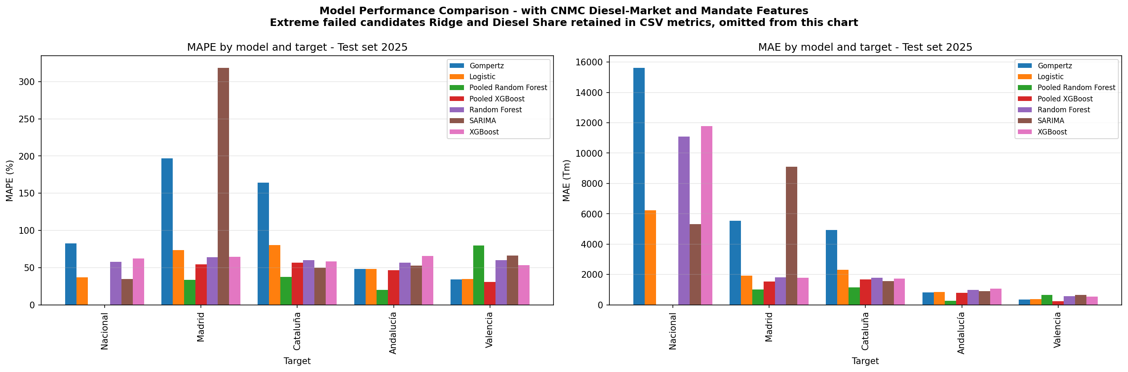
Selected model comparison
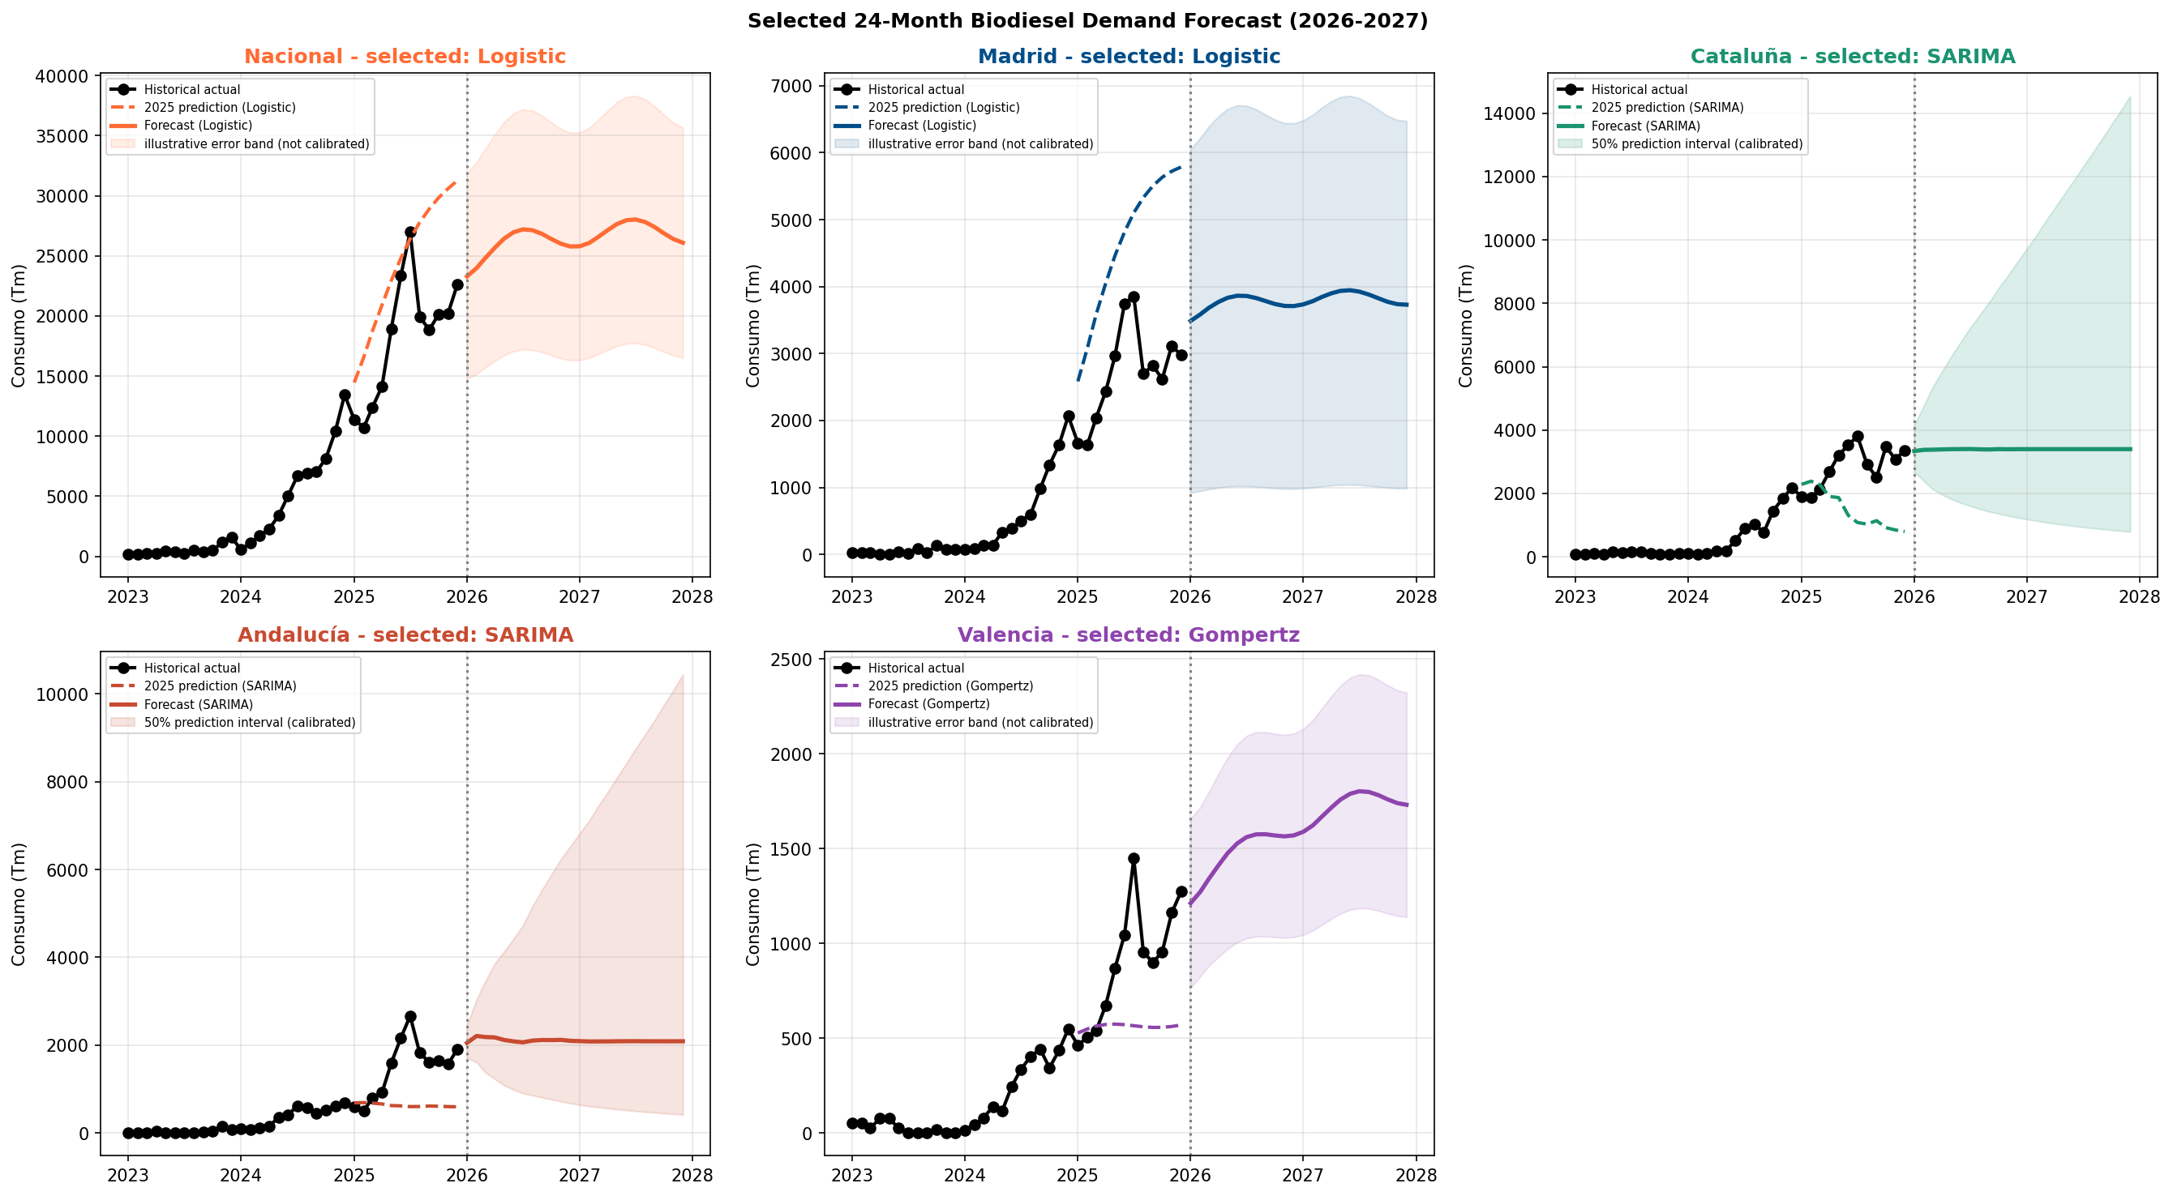
Selected 24-month forecast

5.6 Regional Interpretation
The five selected models fall into two structurally different groups, and the clearest way to read them is by that split rather than by error rank. Three series, the national market, Madrid, and Valencia, are won by saturating growth curves, but they sit at very different points on those curves. The national and Madrid Logistic fits place their saturation ceiling only about 1% above the highest demand already observed in 2023-2025, so both models treat the steepest phase of adoption as essentially complete. Valencia's Gompertz ceiling, by contrast, sits roughly 29% above its observed maximum, implying real remaining headroom for growth (Section 5.9). The other two series, Cataluña and Andalucía, are not at some point on an adoption curve at all: they are won by SARIMA, which models recent month-to-month and year-on-year dynamics rather than a saturation ceiling, and their selected terms are not statistically significant (Section 5.9). They are a genuinely different regime, not a different position on the same curve.
Nacional is selected with a Logistic model. This suggests a national adoption-curve pattern, where demand continues to grow but should not be extrapolated without limits.
Madrid is also selected with a Logistic model, but the holdout error is high. This means the Madrid forecast should be interpreted directionally and validated with additional market information before operational use.
Catalonia is selected with SARIMA. Its forecast is relatively stable, suggesting that recent time-series behavior is more useful than a growth-curve assumption.
Andalusia is selected with SARIMA. The forecast also appears stable, with moderate month-to-month variation.
Valencia is selected with Gompertz. This suggests ongoing growth momentum with a shape consistent with adoption-stage demand.

5.7 Why No Tree-Based Model Was Selected for Any Region
Random Forest and XGBoost are two of the seven headline-eligible candidates evaluated for every target, but the training-only walk-forward selection process never picked either one, for any region, and not by a narrow margin: in every region both tree-based candidates score tens of percentage points of walk-forward MAPE worse than the model that actually won. This is a structural pattern across all five targets, not a near-miss in one or two of them.
The project's own diagnostics point to four reasons, in order of importance:
- Not enough rows relative to the number of inputs. Each target has only 24 training months (2023-2024), and the machine-learning feature set has 17 columns covering lags, rolling means, calendar terms, and lagged macro, diesel-market, and mandate variables. A tree ensemble choosing splits across 17 candidate variables with that few rows has very little data behind any one split, so it tends to fit the idiosyncrasies of 2023-2024 rather than a pattern that generalizes to 2025. This is the same root constraint that makes SARIMAX fail to converge for every target's 2025 holdout fit (Section 5.3): too many free parameters for too few rows, just showing up differently for a tree ensemble (unstable, high-variance splits) than for a likelihood-based model (an outright convergence failure).
- Trees cannot extrapolate past the range of values they were trained on, and biodiesel demand is still on a rising adoption curve. A regression tree predicts the average target value of whichever training rows land in the same leaf as a new input. Once a recursive, multi-month forecast pushes last month's demand above anything the model ever saw in training, which is exactly what happens while demand keeps growing, the model cannot output a value higher than that leaf has ever produced. Over a 12-month-plus recursive horizon, this means Random Forest and XGBoost structurally tend to flatten out instead of continuing the trend.
- This is not a careless-defaults problem. The production pipeline already constrains both models specifically to fight overfitting at this sample size (Random Forest: max depth 3, minimum 3 samples per leaf; XGBoost: max depth 2, learning rate 0.05, with L1 and L2 regularization applied). The performance gap persists even with that regularization already in place.
- A diagnostic pooled-region comparison confirms this is a sample-size effect, not a verdict against tree models for this problem. As a sensitivity check that is never eligible for the headline forecast, the pipeline also fits a pooled version of the same Random Forest and XGBoost that stacks all four regional targets together, roughly four times the effective rows of any single-region fit. That pooled version beats the current production model on the 2025 holdout for all four regional targets: Madrid 33.3% vs. 73.6%, Cataluña 36.4% vs. 50.1%, Andalucía 20.9% vs. 52.6%, and Valencia 31.8% vs. 34.2%. The same algorithm, given more rows, performs much better. That is direct evidence the limitation is the amount of data available per region today, not something inherent to tree-based methods for biodiesel demand. Section 5.10 explains why this better-performing pooled version is still not the selected model.

5.8 Feature Importance: Which Variables Actually Mattered
Random Forest mean-decrease-impurity and XGBoost gain were computed and averaged across all 5 targets as a model diagnostic. This is the only feature-importance artifact the project produces, and it applies only to the two candidate families that were never actually selected (Section 5.7), so it should be read as a diagnostic of the losing candidates, not as a statement about what drives the forecast Repsol is actually being given.
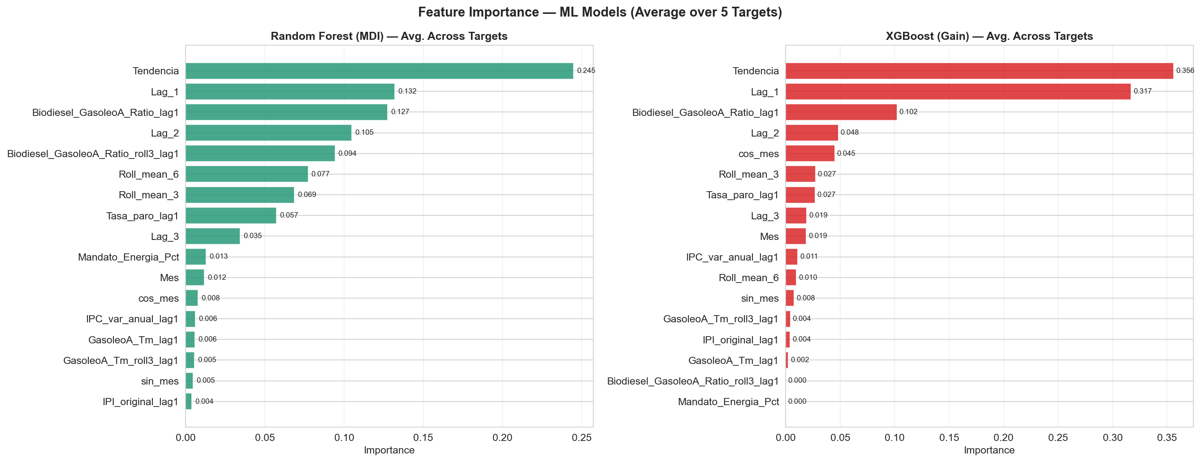
Feature importance, Random Forest and XGBoost, averaged across all 5 targets
Tendencia (the linear trend index) and Lag_1 (last month's demand) together account for the large majority of both models' importance: Tendencia ranks first for both Random Forest and XGBoost, with Lag_1 close behind and outright second for XGBoost. Every macroeconomic, fuel-price, mandate, and diesel-market feature ranks far below both. This is expected, not a sign that a richer signal was found: with only about 24 monthly training rows per target, a tree-based model has little statistical room to separate the contribution of slower-moving inputs from the dominant month-to-month carry-over, so importance concentrates almost entirely on the most recent observation and the overall trend direction. The practical implication for Repsol is that none of the macro, price, or mandate variables this project collected currently move the forecast in a way the data can support; more history, not more variables, is the more likely path to a model that genuinely uses them.

5.9 What Actually Drives Each Selected Model
None of the five selected models are tree-based, so the feature-importance diagnostic in Section 5.8 does not describe any of them. The two model families that were actually selected work very differently from each other:
- SARIMA (Cataluña, Andalucía) forecasts each month from a small number of lag terms: how much demand changed last month and the month before, and how it compared to the same month one year ago. It is the only one of the five selected models that looks at recent actual values at all.
- Logistic (Nacional, Madrid) and Gompertz (Valencia) are saturating growth curves fit directly against elapsed time, plus a fixed monthly seasonal correction. They have no lag terms whatsoever: once fitted, a forecast for any future month depends only on how many months that point is from the start of the series and which calendar month it falls in. They do not look at, or react to, the most recent actual demand figure at all.
Cataluña is fit as (p,d,q)(P,D,Q,m) = (0,1,2)(1,0,0,12) and Andalucía as (1,1,2)(1,0,0,12). An important caveat applies to both: none of the individual lag or seasonal coefficients are statistically significant at the 5% level, for either region (Cataluña's smallest p-value among those terms is 0.337; Andalucía's is 0.089). Only the residual variance term is significant, which confirms there is genuine unexplained noise in the series, not that the specific lag pattern chosen is a real, identified signal. With only 36 monthly observations per region, the data cannot statistically confirm which lag pattern is responsible; the selected order should be read as the most defensible choice available from a small training-only candidate grid, not as a discovered causal mechanism.
Nacional and Madrid (Logistic) both estimate a saturation ceiling only about 1% above the highest demand actually observed in 2023-2025, with the steepest part of the growth curve falling near the end of the observed history (around February 2025 for both). In plain terms, both curves treat the steepest phase of adoption growth as already having happened, so 2026-2027 sits on the flattening part of the curve rather than continued rapid growth. Nacional's seasonal correction is statistically significant but explains only 14% of residual variance; Madrid's seasonal pattern is not statistically distinguishable from noise at all, and should not be read as a real calendar effect at this sample size.
Valencia (Gompertz) tells a different story: its fitted ceiling sits about 29% above the observed historical maximum, meaning the model believes there is still real headroom for demand to grow rather than flattening. Its seasonal correction is statistically significant.
The structural takeaway for Repsol is that once fitted, none of Nacional's, Madrid's, or Valencia's forecasts look at recent actual demand at all; if real 2026 demand comes in above or below what the curve assumed, these three models will not adjust until the pipeline is re-run on new data. SARIMA is the only family among the five that reacts to recent actuals each month, but its own lag terms are not individually statistically significant either. Neither family should be presented to Repsol as a confidently identified causal mechanism; both should be presented as the best-performing structure found at this sample size, which is a materially different and more honest claim.

5.10 Why the Pooled Regional Model Was Not Selected Despite Better Holdout Performance
Section 5.7 showed that a pooled version of Random Forest / XGBoost, trained on all four regional targets stacked together, beats the current production model on the 2025 holdout for every regional target. This raises a fair question: if pooling performs better, why is it not the selected model?
The answer is a deliberate design choice, not an oversight. This project's standing modeling philosophy is one independently-fit model per region: every target is free to be won by any of the seven candidate families, but the winning model's parameters must come entirely from that region's own history. A model whose splits or coefficients are also shaped by another region's rows, however useful that extra data might be, is a different kind of object than "the best model for this region," which is the actual design goal here. Pooling is excluded for that reason, not because the holdout comparison above was unfair to it; that comparison is real and intentionally disclosed precisely so the tradeoff is visible to Repsol rather than hidden. The pooled results remain available in the project's diagnostic outputs as a transparent sensitivity comparison, and are a natural first place to look if more historical data per region becomes available and the one-model-per-region constraint is revisited.

6. Conclusions

6.1 Final Technical Result
The project successfully builds a reproducible forecasting pipeline for Diesel Nexa / biodiesel demand. The pipeline consolidates multiple datasets, creates a master dataset, engineers time-series features, evaluates multiple model families, and generates selected 24-month forecasts for national and regional targets.
The final selected models demonstrate that one algorithm is not sufficient for every region. Logistic and Gompertz models are useful where demand behaves like an adoption curve, while SARIMA is useful where recent temporal patterns dominate. Sections 5.7 to 5.10 show this is not an arbitrary per-region choice: it is backed by a structural explanation for why tree-based and pooled alternatives were not selected, by a feature-importance diagnostic showing which inputs the losing candidates actually used, and by an explicit statistical significance check on the winning models' own coefficients.

6.2 Technical Performance
The model performance metrics show that forecast uncertainty remains high:
- The best MAPE is Valencia at 34.2%.
- The national model has a MAPE of 36.7%.
- Catalonia and Andalusia have MAPE values above 50%.
- Madrid has the highest MAPE at 73.6%.
These errors reflect the nature of the problem. The target series has only 36 monthly observations and appears to be in a growth/adoption phase. High error is therefore expected and should be communicated transparently. Section 5.9 adds a further, more specific caveat: for Cataluña and Andalucía, the SARIMA model's own individual lag and seasonal coefficients are not statistically significant at the 5% level either, so the headline MAPE/RMSE figures should not be read as evidence of a confidently identified mechanism, only as the best-performing structure found at this sample size.
A note on R2. The holdout R2 values in the metrics table are negative for every target, which looks alarming but is not the contradiction it first appears to be. R2 measures error against a flat forecast equal to the test-period mean, and on a series that grew by roughly 230% to 290% between 2024 and 2025 that mean is not a forecast anyone would actually use, so it is the wrong benchmark. The appropriate comparison is a seasonal-naive forecast, in which each month is predicted to equal the same month one year earlier. Two facts follow, and both are reported here in full. First, the standard in-sample MASE is above 1 for all five targets, roughly 1.2 to 3.0; this is inflated by the same scale gap, because the 2025 test period is about three times the size of the 2023-2024 training period and that enlarges every model's error relative to the smaller in-sample naive errors. Second, and more decision-relevant, when each selected model is compared against a seasonal-naive forecast on the same 2025 holdout, every model reduces mean absolute error, by about 5% for Madrid up to roughly 50% for the national series. The honest reading is therefore narrow but real: the models capture the upward adoption trend that both the mean and a no-growth naive forecast miss, which is exactly why R2 looks poor; they should not, however, be presented as having low absolute error, because seasonal naive is itself a weak benchmark on a fast-growing series. Both comparisons are computed in scripts/07_selected_model_drivers.py and written to data/outputs/selected_model_mase.csv for inspection.

6.3 Business Impact
The project provides a structured forecasting foundation for Diesel Nexa planning. It allows stakeholders to compare national and regional demand expectations, understand model uncertainty, and identify where further data collection would improve reliability.
The forecast is most useful for:
- Strategic planning.
- Regional prioritization.
- Medium-term supply discussions.
- Scenario thinking.
- Executive communication.
The forecast should not be treated as a final operational planning model without further validation.

6.4 Practicality for Implementation
The current implementation is practical because it is reproducible, transparent, and modular. It can be rerun when new monthly data becomes available. The use of saved intermediate outputs also makes it easier to audit assumptions and update specific steps without rebuilding the entire project manually.
The next stage should focus on improving model reliability by adding more historical observations, regional macroeconomic variables, regulatory event features, and stronger scenario assumptions.

6.5 Business Recommendations for Repsol
These recommendations are intentionally framed as planning guidance, because the current project does not include Repsol internal sales or margin data.
1. Use the current forecast as a market-demand scenario, not as a direct Repsol sales forecast.
2. Treat regional forecasts as directional signals and monitor actuals closely, especially where the diagnostics are weakest: Madrid (Logistic) shows by far the highest holdout error at 73.6% MAPE, while for Cataluña and Andalucía (SARIMA) the individual lag and seasonal terms are not statistically significant (Section 5.9). These are two separate caveats and should not be read as one.
3. Present the selected forecast (SARIMA / Logistic / Gompertz, one model per region) as the official headline model set, and keep the non-selected candidates (SARIMAX, Ridge, Random Forest, XGBoost, plus the diagnostic-only pooled regional ML and Diesel Share candidates) visible as transparent comparison baselines, not hidden alternatives.
4. Build a Repsol-specific demand layer on top of the market forecast using internal sales, pricing, station, availability, and customer data.
5. Use the model outputs to support regional scenario planning, not single-point operational commitments.
6. Re-run the pipeline when newer actual demand data becomes available and track forecast drift by region.
7. For business decisions such as inventory, pricing, and logistics, require internal data validation before acting on model outputs.
8. Model the 2027 regulatory gap as an explicit, separate scenario. Spain's 14% blending obligation for 2026 is enacted (RD 5/2026), but no concrete mandate for 2027 is yet in force; the 2027 path in this project is a projection, not law. Neither the statistical prediction intervals nor the scenario band in the supporting mini-model represents this policy risk, because both describe uncertainty in the pace of adoption around a fitted curve, not the discrete risk of a mandate arriving, changing, or being delayed. Because the target series has not historically moved mechanically with mandate levels, the right next step is not to multiply a mandate percentage into the forecast but to add a clearly-labelled regulatory scenario layer that models 2027 under enacted, delayed, and stronger-mandate cases as a distinct source of uncertainty.

6.6 Priority Data Roadmap
In priority order, the following additions would most improve this forecast's operational usefulness for Repsol:
Priority | Data / Modeling Improvement | Purpose
1 | Add Repsol sales by station, product, customer type, and month. | Convert market-demand forecasting into Repsol-demand forecasting.
2 | Add product availability, inventory, and stockout history. | Separate demand from supply constraints.
3 | Add Repsol pricing, discounts, promotions, and B2B contract terms. | Estimate commercial levers and price sensitivity.
4 | Add customer/fleet segmentation and loyalty behavior. | Improve regional and station-level demand segmentation.
5 | Add competitor/local market context around stations. | Explain local substitution and market-share differences.
6 | Extend the actual demand history when new 2026 data becomes available. | Strengthen backtesting and reduce reliance on a single 2025 validation year.
7 | Develop a two-layer model: market demand first, Repsol share second. | Keep the current capstone model useful while making it operational for Repsol.

6.7 Final Recommendation and Caution
The recommended business use is to treat the current forecasts as a first strategic demand-planning layer. They are valuable for understanding likely direction and relative regional behavior, but they should be combined with expert judgment and additional market information before making binding operational decisions.
The most important business message is that the current project is a solid market-demand forecasting framework, but not yet a full Repsol operational forecast. The next step is not simply a more complex algorithm; it is adding Repsol internal data so the model can distinguish market growth from Repsol-specific sales, availability, pricing, customer behavior, and logistics constraints.

Bibliography
Comisión Nacional de los Mercados y la Competencia (CNMC). Petroleum product consumption statistics and diesel-market data used to reconcile biodiesel demand and construct diesel-pool context variables. This is the project's verified, reproducible source for the biodiesel target series itself (Section 2.1), not only for contextual variables.
Corporación de Reservas Estratégicas de Productos Petrolíferos (CORES). Certified biofuel and biodiesel consumption data retained as historical and supplementary reference material. Not read by any notebook or script in the reproducible pipeline; superseded by the CNMC reconciliation in Section 2.1 as the project's lineage source.
Instituto Nacional de Estadística (INE). Macroeconomic indicators used in the project, including industrial production, consumer price variation, and unemployment rate variables.
Fuel-price datasets for Spain, 2023-2025. Regional gasoline and diesel price observations processed into monthly autonomous-community price features.
Brent crude oil monthly price data, 2023 onwards. International crude oil price context used as an energy-market explanatory variable.
Project repository artifacts. README.md, DATA_AUDIT_REPORT.md, INDEPENDENT_AUDIT_REPORT.md, production scripts, notebooks (in particular notebooks/12_business_interpretation_and_recommendations.ipynb, the source for Sections 5.7-5.10 of this report), and generated outputs in the Repsol capstone repository.
Python Software Foundation. Python programming language used for data processing, modeling, and report automation.
pandas, NumPy, statsmodels, scikit-learn, XGBoost, matplotlib, and seaborn documentation. Python libraries used for data manipulation, statistical modeling, machine learning, visualization, and evaluation.

Appendix: Additional EDA and Diagnostic Figures
This appendix collects the per-region train, validation, and forecast charts for the five selected models; they support the regional interpretation in Section 5.6 and are placed here rather than in the main body for length. The remaining exploratory and diagnostic figures generated during this project (price, correlation, and seasonal-decomposition charts) are kept in the project repository under reports/figures/.
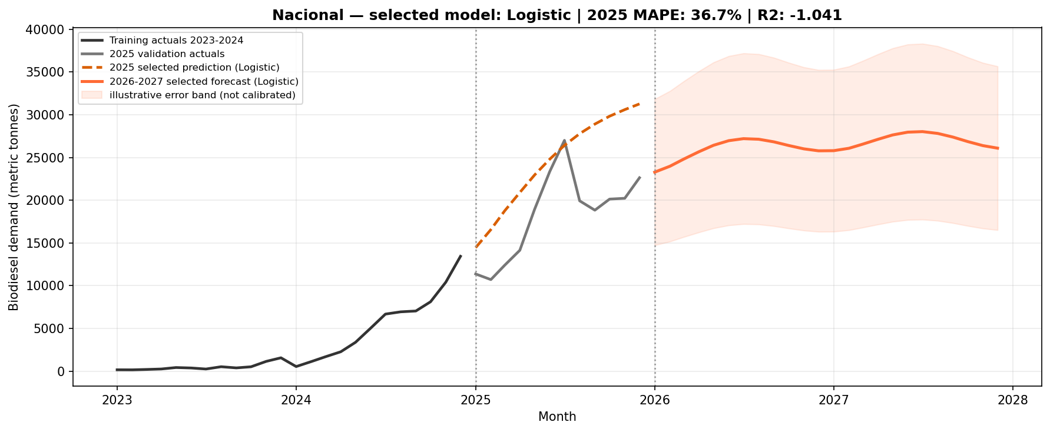
National business forecast
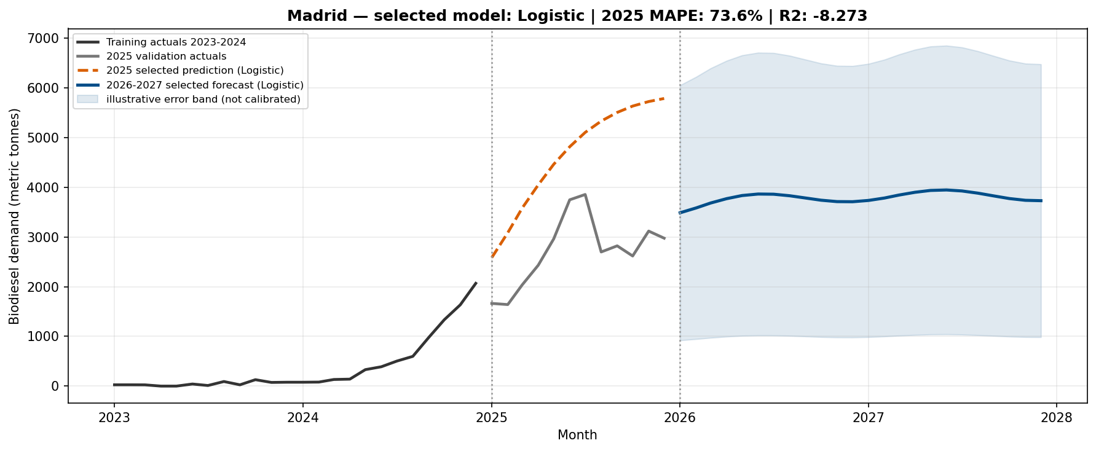
Madrid business forecast
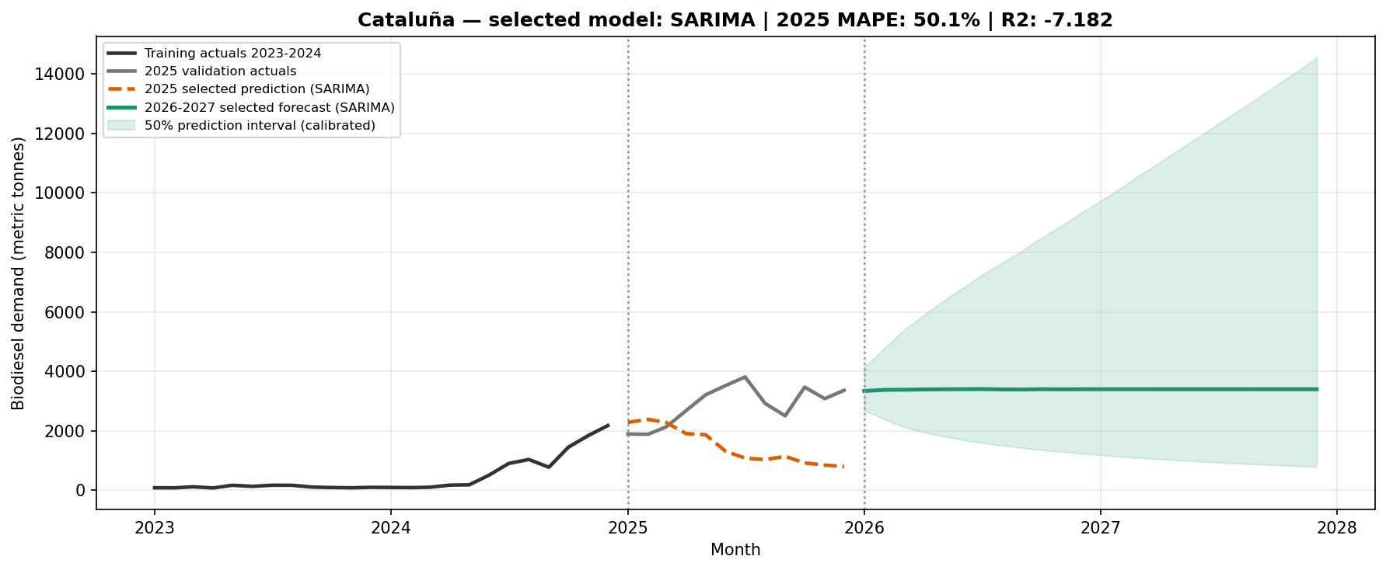
Catalonia business forecast
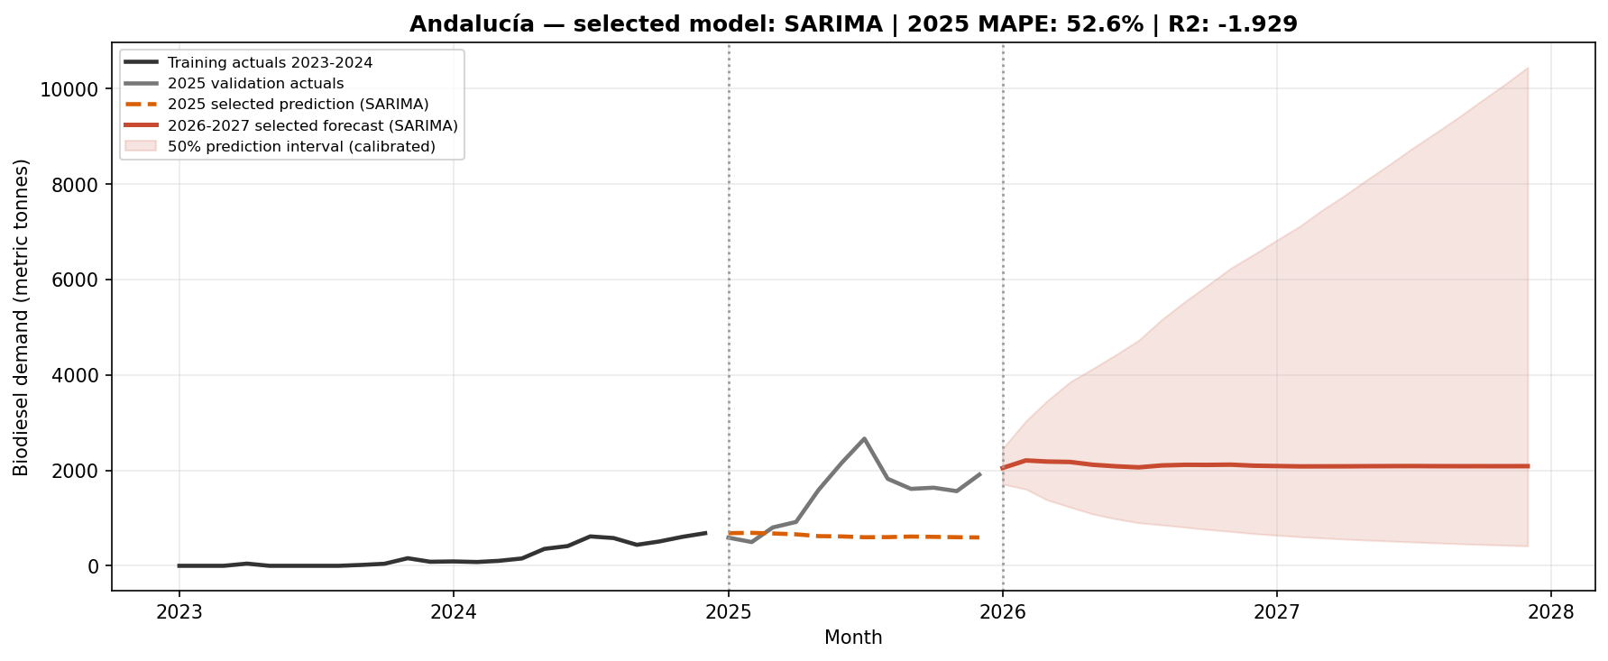
Andalusia business forecast
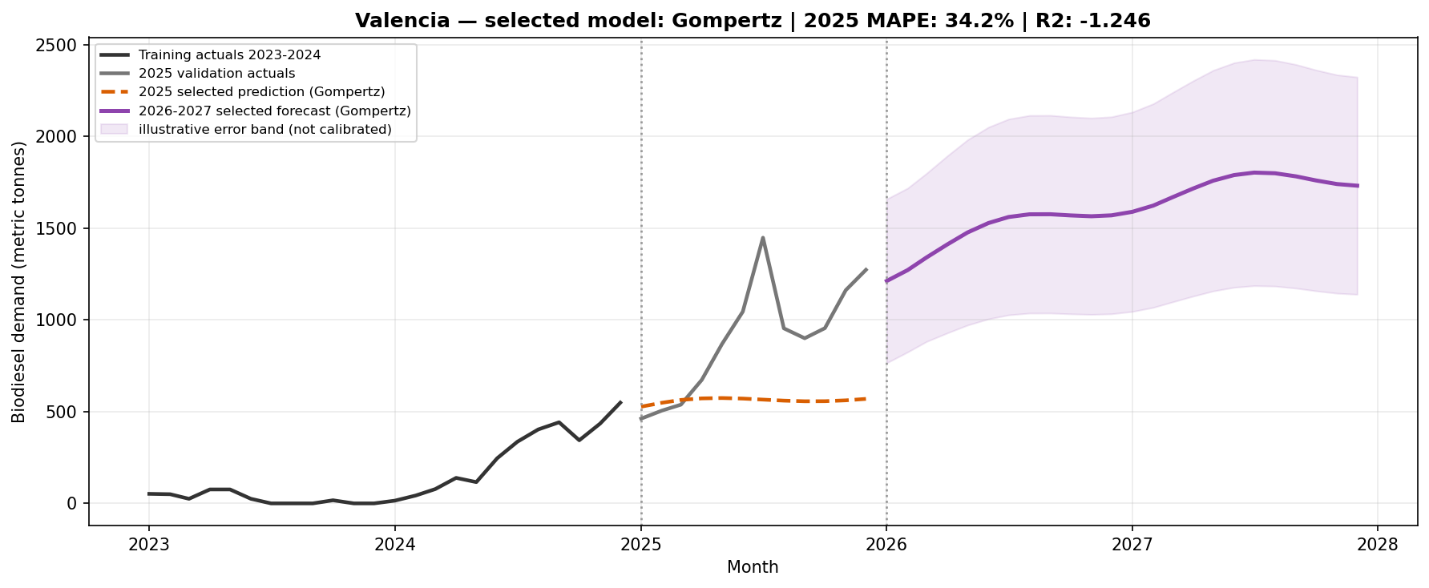
Valencia business forecast
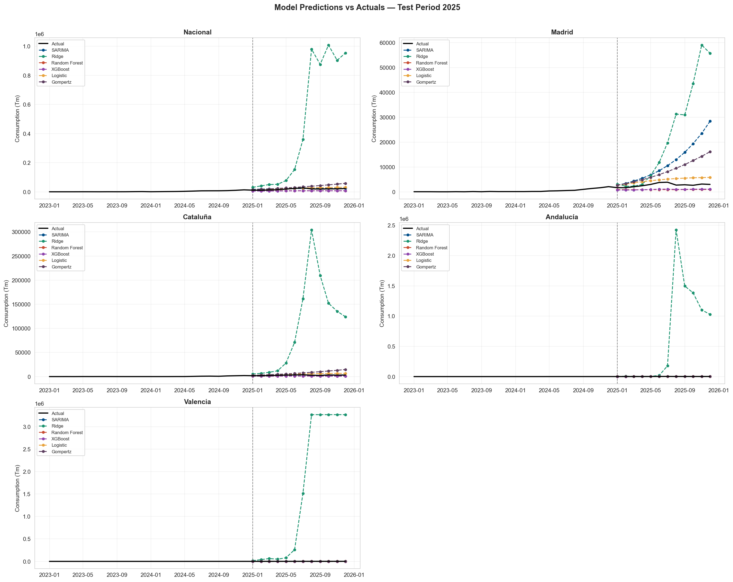
Predictions versus actuals
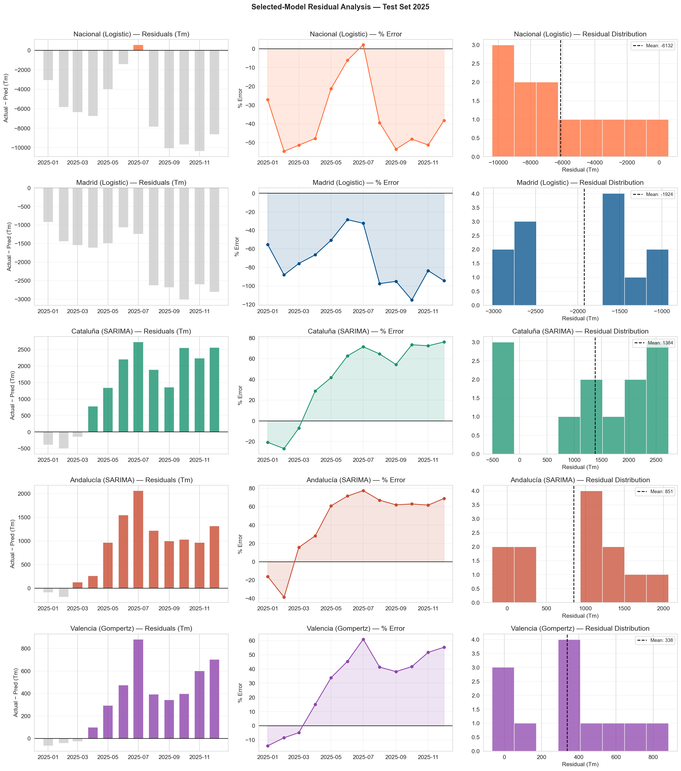
Residual diagnostics

